FUTURE NEW HIRE
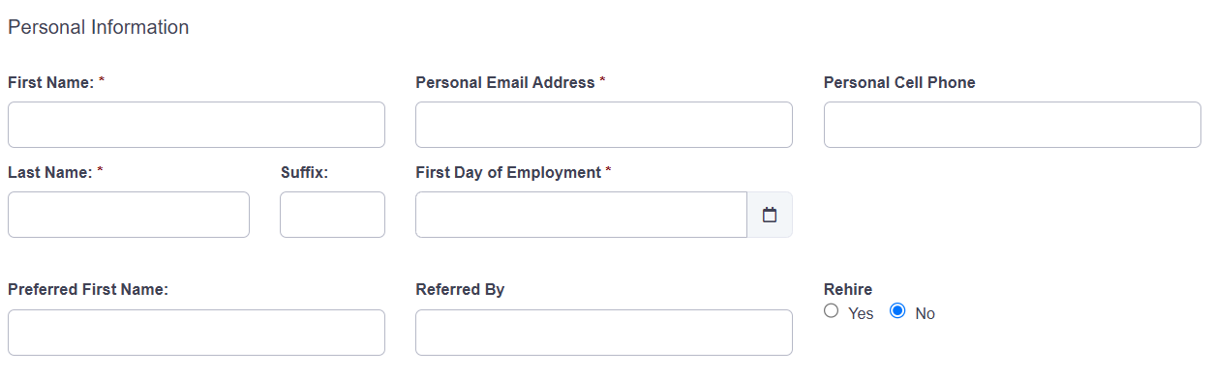
PERSONAL INFO | DESCRIPTION
First/Last Name | If Preferred First Name is empty, the First Name will be used for the AD account, email, and Viewpoint.
Preferred First Name | If populated, this value will be used for the AD account, email and Viewpoint; if left blank, it will use the data in the First Name data.
Personal Email | Used for:
Personal Cell | Used for:
First Day of Employment | Date selector
Preferred Name | Used in AD account, email address, and Viewpoint.
Referred by | Informational only - Data is sent in the general email that summarizes data entry to hiring manager. Does not trigger any action/process.
Rehire | Informational only – Data is sent in the general email that summarizes data entry to hiring manager. Does not trigger any action/process.

Position Information – Non-Union
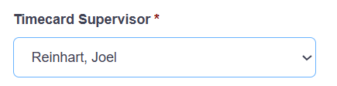
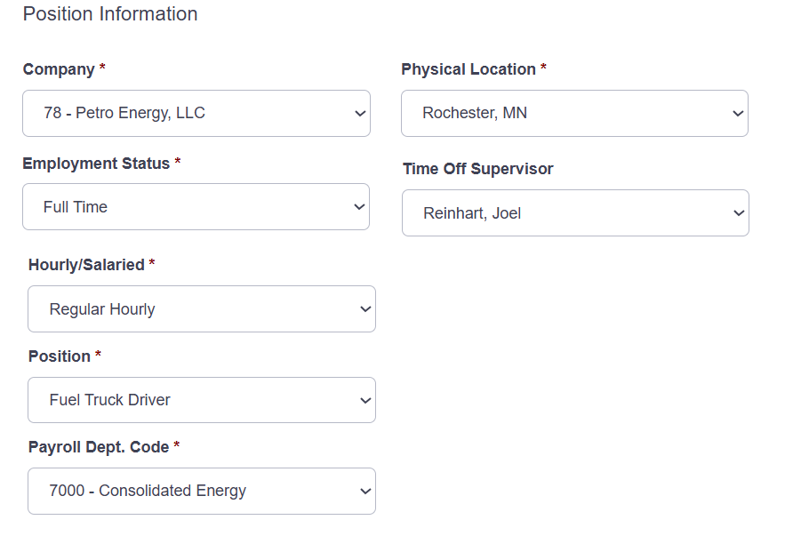
Field | Description | Notes
Company | Drop down with be all available hiring companies.  How do we control the drop down content? | Split Energy / Mathy / Pavement – based on who is logging in and the user’s group, show the appropriate Company options. Use Azure Groups – this will allow us to handle exceptions.  PRCo
Employment Status | 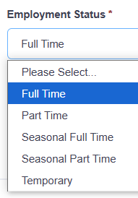 | SP [dbo].[EmploymentStatus_List]  Company 19 will have Union statuses.
Hourly/Salary |  | Non-Union option only  SP [dbo].[HourlySalaried_ListGetbyCompanyID]
Position |  | SP [dbo].[Position_ListGetbyCompanyID]
Payroll Dept Code |  | dbo].[PayrollDeptCode_ListGetbyCompanyID]
Functional Department | Need Use Case to bring back | Currently not on PVMT
Time Off Supervisor | Driven off Payroll Department Code to present the options | Non-Union option only  Currently not on PVMT  New data element in Vista?
Physical Location |  | [dbo].[PhysicalLocation_List]
Timecard Approver | Driven off Payroll Department Code to present the options | ** If Salary is selected as Employment Status, do not show  Currently not on PVMT  New data field in Vista

Position Information – Union
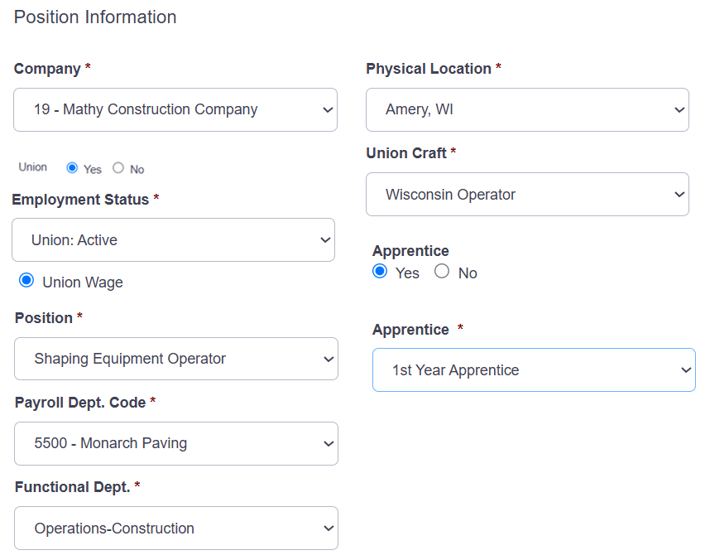
Field | Description | Notes
Company | Drop down with be all available hiring companies | List will be driven by user’s access security?  SP [dbo].[Company_Listfor DivGetbyID]
Union |  | **If the Company select is 19 - Mathy Construction Company, then present this option
Employment Status | 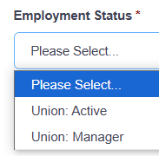 | **If Union is selected to Yes, these are the available options.  SP [dbo].[EmploymentStatus_List]
Position |  | SP [dbo].[Position_ListGetbyCompanyID]
Payroll Dept code
Functional Department | Waiting on Use Case | Currently not on PVMT
Union Craft |  | ** If Union is selected to Yes, show this parameter
Union Wage |  | ** If Union is selected to Yes, show this parameter
Physical Location
Payroll Dept Code |  | [dbo].[PayrollDeptCode_ListGetbyCompanyID]
Apprentice | Yes / No
Apprentice Year | Select years of Apprentice  **Shows when Apprentice is selected as Yes

To Be Removed:
Field | Description | Notes
Timecard Method | 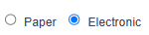 | If Salary is selected as Employment Status, do not show | Currently not on PVMT
Timecard Type |  | ** If Timecard Method is selected to Electronic, show this parameter.  There is some logic built in right now. | Currently not on PVMT
Timecard User Group | Driven off Payroll Department Code to present the options | ** If Timecard Method is selected to Electronic, show this parameter | Currently not on PVMT
Primary HR Representative |  |  | Currently not on PVMT
Secondary HR Representative |  |  | Currently not on PVMT

Credit Cards
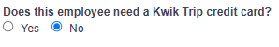
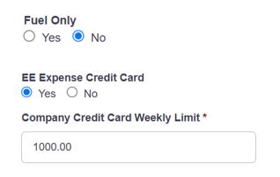



Kwik Trip Card | Yes / No
Company Expense Card | Yes / No | If yes, show the next three options:
Fuel Only Credit Card | Yes / No
EE Expense | Yes / No
Weekly Limit
Fuel Cardlock Access | Yes / No
Cardlock – ship address | Populate with the Physical Location used above | **If Fuel Cardlock is selected as Yes

Company Vehicles Details
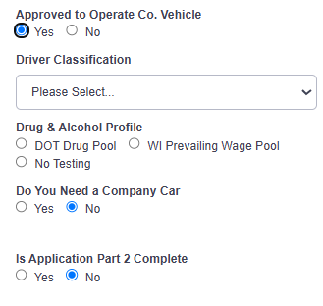
Approved to Operate? | Yes / No
Classification |  | ** Show if Approved to Operate is Yes
D & A Profile |  | ** Show if Approved to Operate is Yes
Company Car | Yes / No | ** Show if Approved to Operate is Yes
Application Part 2 | Yes / No | ** Show if Approved to Operate is Yes

Building Access
Mathy/Energy
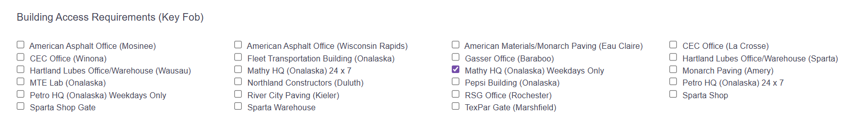

Pavement
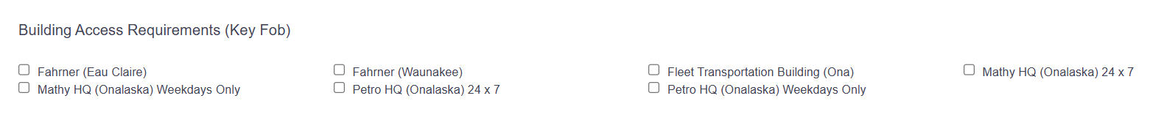
IT Related Information
If the data entered specifies this is a “non-salary” employee, ask:
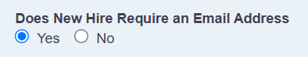
If the data entered specifies “salary” assumptions:
- Will need an email address
- Will need an E5 M$ license

IT Hardware
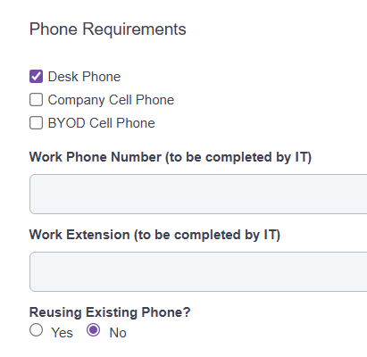
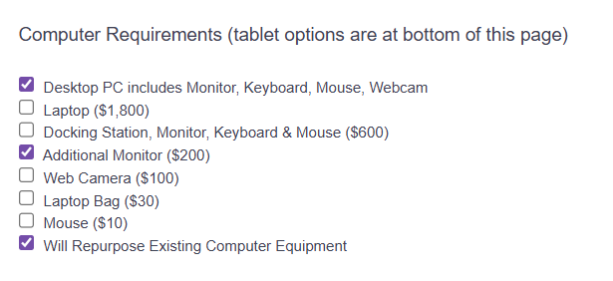

Mathy Tablet Profiles:
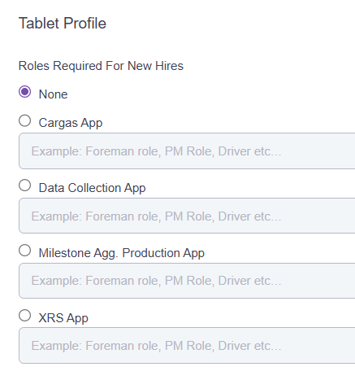
Pavement Tablet Profiles:
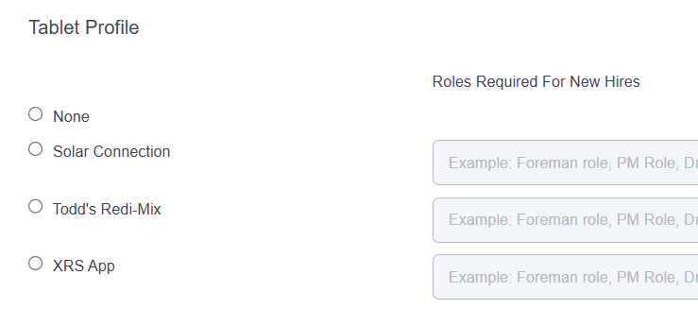
Add to UI: All items will be delivered to [Physical Location selected] unless noted here: [text box]

Software
Pavement and Mathy/Energy will have two lists. Lists are stored in the Application Table in each for the New Hire DBs.
